PROJECT HANDBOOK

By SASBS(Sudip Parajuli, Ankit Karki, Sudip Ghimire, Bishal Poudel, Sabin Poudel) Team

***V.R.B. real estate and Consultant***

# Revision

|  |  |  |  |
| --- | --- | --- | --- |
| Version Number | Date approved | Approved by | Description |
| 1.0 | 2020-09-20 | Ankit Karki | Project handbook |

# **Preface**

This project is about developing website and android app for V.R Buildtech where this document contain all the related document that is needed for this project. This is our first document which contain document up to pat four where it has cover the process model, plan , dividing task and what method and technique we are using. The technique we are using is SCRUM method. This methodology includes the sprints in which evolution of the project is done on scheduled dates to makes project dates.

Contents

Revision 2

**Preface** 2

**Vision Statement** 4

**Overview** 4

**1.** **Introduction** 4

**1.1** **Project Overview** 4

**1.2** **Project Deliverables** 5

**1.3** **Evolution of the Handbook** 5

**1.4** **Reference Materials** 5

**1.5** **Definitions and Acronyms** 5

**2.** **Organization** 7

**2.1** **Process Model** 7

**2.2** **Organizational Structure** 8

**2.3** **Organization Boundaries and Interfaces** 9

**2.4** **Project Responsibilities** 9

**3.** **Managerial Process** 10

**3.1** **Management Objectives and Priorities** 10

**3.2** **Assumptions, Dependencies, and Constraints** 11

**4.** **Technical Process** 11

**4.1** **Methods, Tools, and Techniques** 11

**4.2** **Software Documentation** 13

**5.** **High level Project Plan** 14

**6.** **Non-functional Requirements** 15

**6.1** **Platform** 15

**6.2** **Communication** 15

**6.3** **Performance** 15

**6.4** **Security and Privacy** 16

**6.5** **Audience, Usability and Accessibility** 16

**6.6** **Reliability** 16

**6.7** **Modifiability** 16

**6.8** **Economic** 16

**6.9** **Legal** 16

**6.10** **Standards** 16

**7.** **Software and Systems Architecture** 17

**7.1** **Architecture objectives** 17

**7.2** **High-level architecture** 17

**7.3** **System context** 18

**7.4** **User Interface / Interaction Design** 18

**7.5** **Data model and software design** 20

**7.6** **Assumptions** 22

**7.7** **External Dependencies** 22

**8.** **Reference** 22

# **Vision Statement**

|  |  |
| --- | --- |
| Project Start Date | 20/07/2020 |
| Project end date | 10/10/2020 |
| Project type | Document |
| Project Manager | Ankit Karki |
| Estimated Budget | $70000 |

# **Overview**

We are developing the website and android application for V.R. Buildtech, Company according to the requirement of our client. They are currently using 99acers.com and magicbricks.com as platforms for advertisement. The aim of the project is to develop a portal for registered & existing customers to login, raise issues of concern and monitor the reports of the daily work. The website also will list all the services undertaken by the company and used as a marketing tool for a prospective client. Company also wants us to implant notification mechanism that sends email alerts and SMS notifications to customer. Client/company also want us to link their social media, application, and the webpage with each other. And, from the first client meeting as per their request, they want us to put a 3D effect of the house or apartment or else.

# **Introduction**

## **Project Overview**

The project vision document is the main required document to explain about what the project is all about: what the services and product to be developed and make the limitation to know when we have achieved those limitation or objectives. This document is also about what to in lude with in and out of the scope, which should be in term of project boundaries and the opinion and information which is essential to support those boundaries.

Plan to start this project at the same time as starting the project grant. Properly defining the last part of the project should better allow the charter to be finished at time of signing.

The project is to develop application for android and as well as for the desktop (web app) for the V.R. Buildtech. They are currently using 99acers.com and Magicbricks.com platforms for the sales and advertising and growth.

## **Project Deliverables**

|  |  |  |  |
| --- | --- | --- | --- |
| No | TASK | DUE DATE | RESPONSIBILITIES |
| 1 | User manual | 21 Aug | SASBS Teams |
| 2 | Installation manual | 21 Aug | SASBS Teams |
| 3 | Technical documentation | 22 Aug | SASBS Teams |
| 4 | Project overview | 23 Aug | SASBS Teams |
| 5 | Project backlog | 30 Aug | SASBS Teams |
| 6 | Project handbook | 23 Aug | SASBS Teams |
| 7 | Meeting | 25 Aug | Ankit Karki |
| 8 | Sprint documentation | 13 Sep | SASBS Teams |
| 9 | Design documentation | 15 Sep | SASBS Teams |
| 10 | Presentation | 17 Sep | SASBS Teams |

## **Evolution of the Handbook**

As the project will continue when there is any kind of problem the team member will contact the project manager so he will send the notice to every team member, those people will be making change according the problem to solve it as we will conduct online meeting in the Zoom/Teams group. After finding out the problem the project manager will change in the handbook in form of sprints. These changes are schedule after the completion of every sprint. As the project manager update the handbook he will send message to every group member about it as group member will response to it. As every group of five member will be working together as the request of the project manager. Every change is responsible to the project manager.

## **Reference Materials**

http://www.ieee.org/documents/ieeecitationref.pdf

http://www.apastyle.org/

https://www.denysys.com/blog/5-benefits-of-agile-methodology/

https://blog.prototypr.io/software-documentation-types-and-best-practices-1726ca595c7f

## **Definitions and Acronyms**

|  |  |
| --- | --- |
| Client | V.R. Buildtech |
| Company | V.R. Buildtech |
| We | Teams who are working on the project |
| SASBS | Team name |
| Users/customers | The one who uses the product or the client of V.R. Buildtech. |

|  |  |
| --- | --- |
| **Terms** | **Definitions** |
| Reset Password | A link that allow register user to reset the users details with verification. |
| Timeline | News Feed or a page to view the post or advertisement that other user has posted. |
| Service Category | A category of services that is linked to a user profile which provide particular service to their clients. |
| Post Settings | Settings where a user can edit or delete their post. |
| Add Event | A post page where you can add the events like concerts, function and festival events by the logged in user. |
| My Favourites | Page where a logged in user can save the posts, services and events as a thumbnail. |
| User Menu | A user menu for a logged in user to view their profiles and also used as a log out system. |
| Manipulate | Settings where an admin can add, update, delete the data or post of the user. |
| Contact Us | Page where a user can contact the admin to report any issue through email, text or through a social media. |
| SADD | Software Architecture and Design Document |
| SPMP | Software Project Management Plan. |
| Database | Where all the data are stored. |
| Sitemap | A page where all the links of website pages are presented. |
| Verification | A process where a login user needs to verify their email and phone number. |
| Advertisement | A promoting notice of the service posted on the website. |
| Discount Promo Code | An offer code provided by the service provider, to provide special offer to clients towards their service, posts like discount, senior discount and so on. |
| Filter Post | An option to choose and view the website services and offers in the way a user wants |

# **Organization**

## **Process Model**

Agile methodology is a procedure by which a group can deal with an undertaking by separating it into a several phases and including consistent joint effort with partners and constant improvement and emphasis at each stage. The Agile approach starts with customers depicting how the final result will be utilized and what issue it will unravel. This explains the client's desires to the undertaking group. When the work starts, groups cycle through a procedure of arranging, executing, and assessing — which may very well change the last deliverable to meet the client's requirements better. Continuous collaboration is key, both among team members and with project stakeholders, to make fully-informed decisions.

As this project has been separated into different five sprints and will be covering different user stories in our project.AS the sprint is completed the useful one will be use as a part of the project.

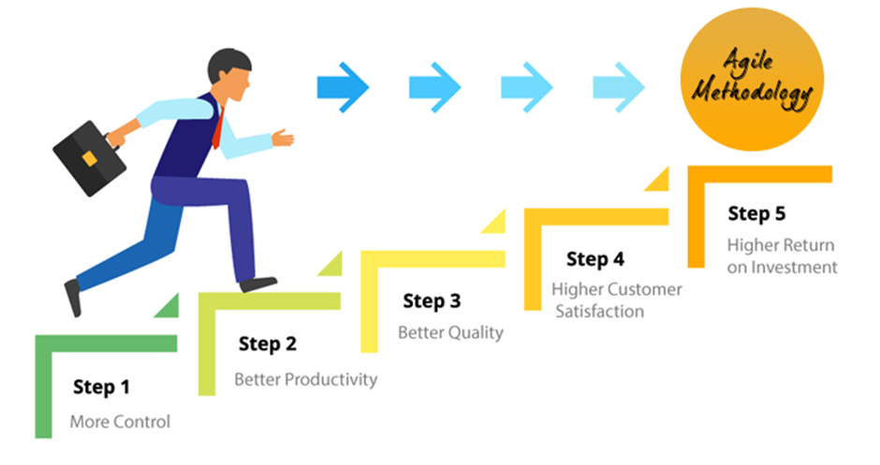

https://www.denysys.com/blog/5-benefits-of-agile-methodology/

Each sprint has time to finish so project will be completed in the time:

|  |  |
| --- | --- |
| Sprints | Estimated time |
| Iterative 1 | 13-08-2020 |
| Iterative 2 | 20-08-2020 |
| Iterative 3 | 11-09-2020 |
| Iterative 4 | 18-09-2020 |

## **Organizational Structure**

Project manager (Abbas/Haroon)

Ankit Karki (Leader)

Sabin Poudel

(Team Member)

Bishal Poudel

(Team Member)

Sudip Ghimire

(Team Member)

Sudip Parajuli

(Team Member)

The project will be divided so that all team member has equal responsibilities toward the project. The task will be divided by project leader and assigned to every group member according to their skill. Project manager will look after how team member are going with their task and will be conducting online meeting to be inform about the task as is there is any problem or we can make update on the project before moving future so later there will be no problem. Every changes done by team member would be inform to the project manager so that later after the project is approved there will be no change in the project.

## **Organization Boundaries and Interfaces**

As it is important to have good relation with the client or stakeholder where our team member will be always be doing their work within their boundaries where they will not go against the boundaries will would have bad impact to the project which isn’t accept by us. So it is responsible to our client that they should be up to date with the client requirement. Project manager will be conducting meeting with the client as well as team member whether the project is running in the right track or not. It is the important part that the client requirement is fulfilled as this project is mostly for our client so every arear should be listed or done carefully as per the client satisfaction.

## **Project Responsibilities**

|  |  |  |  |
| --- | --- | --- | --- |
| Role | Name | Responsibilities | Email |
| Owner | SASBS | Providing every kind of document that are need to be done. | Ankitkarki747@gmail.com |
| Project leader | Ankit Karki | Managing the team. Dividing task to the every team member according to their skills. Look after every requirement of the project and lead the team member towards the goals.  And work with the team to meet the goals. |  |
| System analyst | Sabin Poudel | Analysing the requirement for the system consulting with clients and another related person. Help another team member in all department as well. |  |
| Test Analyst | Sudip Parajuli | Testing their data conducted in the test cycle suggesting if wrong what improvement can be done as well as collecting feedback.  Help another team member in all department as well. |  |
| Programmer | Sudip Ghimire | Coding specialist, writing the code for the application software, and looking after every program that is created.  Help another team member in all department as well. |  |
| Documentation | Bishal Poudel | Documenting the project required document that are run in the project.  Help another team member in all department as well. |  |

# **Managerial Process**

## **Management Objectives and Priorities**

This Project aims to develop a portal for registered & existing customers to login, raise issues of concern and also monitor the reports of the daily work. The website also should list all the services undertaken by the company and used as a marketing tool for a prospective client. For the completion of the project it requires deep knowledge about the various types of tool and software that are going to be used in the project and how the team member is going to use the tools to fulfil the requirement .As there can be occurrence of conflict will impact the project where every team will be aware of that and they will be consider handling there thought that are affecting to the other team member as they have some issue will other team member they will first go with project manager and will be resolve that problem so project will run smoothly as finish in the require time.

## **Assumptions, Dependencies, and Constraints**

An assumption is what you believe to be true. These are anticipated events or circumstances that are expected during project’s life cycle. Assumptions may not end up being true. Sometimes, they can be false and it may affect your project. This adds risk to the project. As here are the some assumption:

* As all team member will give up to date about the project to the project manager so that later there wouldn’t be any kind of the problem in the project.
* Every team member should look what are the client requirement and how can we meet the goal of the client with using their techniques to make the project user friendly.
* The data of the client will be restore in the computer.
* After the completion of project the client can log into the webpage using their ID.

Constraints  
There will be consideration of time, cost and so on the project.

* The project will be finish in the estimated time.
* The project will be quality as per the requirement needed.
* Everyone will be look after the requirement time as per the material requirement.
* There will be no problem in the salary of the employee.
* The project should have minimum financial aid requirement.
* Every equipment will be supply according to save the time to maintain the time allocate.

Dependencies

* It is compulsory that employee are trained properly so that they shouldn’t depend on other.
* There should be proper supply of hardware equipment to run the project properly.
* If some problem occur they need to contact there project manager.

# **Technical Process**

## **Methods, Tools, and Techniques**

Scrum is an agile way to manage a project, usually software development. Agile software development with Scrum is often perceived as a methodology; but rather than viewing Scrum as methodology, think of it as a framework for managing a process. In the agile Scrum world, instead of providing complete, detailed descriptions of how everything is to be done on a project, much of it is left up to the Scrum software development team. This is because the team will know best how to solve the problem they are presented.

https://www.mountaingoatsoftware.com/agile/scrum

For this one we use :

1-Product backlog

-A Product Backlog is rarely finished. Its most punctual improvement spreads out the at first known and best-got prerequisites. The Product Backlog advances as the item and the earth in which it will be utilized develops. The Product Backlog is dynamic; it continually changes to distinguish what the item should be proper, serious, and helpful. In the event that an item exists, its Product Backlog additionally exists. This is a continuous procedure where the project owner and the Development Team work together on the subtleties of Product Backlog things. During Product Backlog refinement, things are checked on and modified.

2-Sprint Backlog

-The sprint backlog is a list of tasks identified by the Scrum team to be completed during the Scrum sprint. During the sprint planning meeting, the team selects some number of product backlog items, usually in the form of user stories, and identifies the tasks necessary to complete each user story. Most teams also estimate how many hours each task will take someone on the team to complete.

Tools and Techniques

|  |  |
| --- | --- |
| Tools Techniques | Description |
| CSS3 | CSS3 is a language that describes the style of an HTML document.  CSS3 describes how HTML elements should be displayed. |
| HTML | HTML refers to links that connect web pages to one another, either within a single website or between websites. Links are a fundamental aspect of the Web. By uploading content to the Internet and linking it to pages created by other people, you become an active participant in the World Wide Web. |
| Google Doc | Google doc is the platform where we can save our document in a form of cloud. |
| MySQL | It is related to create table on DBMS with the help of entities. |
| Lucid chart | Lucid chart is the online platform where we can draw different type of prototype diagram. |
| PHP | A server scripting language used in websites that is connected to the database for the verification of user, login, retrieve and creating the account of the website. |
| WampServer | WampServer is a software bundle (Apache, MySQL, and PHP) which is used for web development and internal testing. |
| Notepad ++ | Notepad++ is a powerful text editor for windows which allow user to edit many languages including HTML, CSS, JAVASCRIPT etc. |
|  | |
|  | |
|  | |

## **Software Documentation**

**System documentation** represents documents that describe the system itself and its parts. It includes requirements documents, design decisions, architecture descriptions, program source code, and help guides.

**User documentation** covers manuals that are mainly prepared for end-users of the product and system administrators. User documentation includes tutorials, user guides, troubleshooting manuals, installation, and reference manuals.

**Process documentation** represents all documents produced during development and maintenance that describe… well, process. The common examples of process documentation are project plans, test schedules, reports, standards, meeting notes, or even business correspondence.

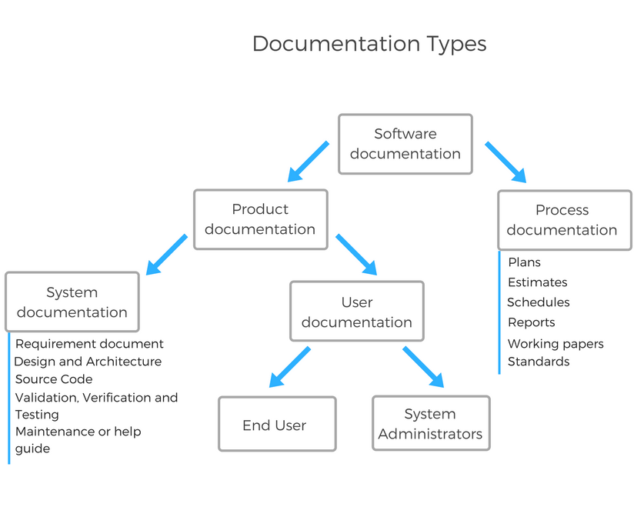

# **High level Project Plan**

|  |  |
| --- | --- |
| SPRINT | GOAL |
| 1.Iteration/Construction: | The project team begins to work on the project’s development using software implemented with the agile method focusing on iteration requirements and feedback. |
| 2.Design | To design any kind of website there must be specific requirements. To fulfil the goals of the website mapping, planning, making and testing should be done. A Design Sprint can be used when any of the following  conditions met their goals. A quick solution is required; The challenge you’re facing is big and complex; Design include implementation of database. |
| 3.Documentation | Process documentation represents all documents produced during development and maintenance that describe… well, the process. The common examples of process-related documents are standards, project documentation, such as project plans, test schedules, reports, meeting notes, or even business correspondence. |
| 4.Development | In this phase we will be looking forward the development of SQL queries, writing the code for the website. Adding different kind of images and |
| 5.Testing | In this phase we will be looking for testing the website we will be using testing tools that are need for the final test of website. |

# **Non-functional Requirements**

In developing the website for this project, key elements business model that are necessary to ensure the success should be resolved at the requirement stage of the development. This website will be designed in a way to achieve certain goals. Non-functional requirement is a requirement that specifies criteria that can be used to judge the operation of a system, rather than specific behaviours. They are contrasted with functional requirements that define specific behaviour or functions. Therefore, the non-functional requirements of this website along with the importance are discussed:

## **Platform**

This non-functional requirement includes Software/Hardware Environments. The hardware environments that our system must operate are computers, laptop or mobile phone. The software environments that can be used are: My SQL, Amp server, Notepad++, JavaScript, Html, Php, CSS, Dreamweaver. The platforms includes computer's architecture, operating system, or programming languages.

## **Communication**

The project may use the communication system such as wi-fi, radio protocols, LTE-A, and wi-fi-Direct or frequencies such as digital communications. The communication plan describes the approach for communicating and collaborating on this website project. The plan identifies the audiences for the project, the information to communicate and the communication methods to use. The browser will communicate with the website to fetch the required data. The website has to connect with database in order to access available data, perhaps that requires MySQL.

## **Performance**

Performance of the website depends primarily on the quality of coding of the website along with internet connection and network. There is a chance of high traffic on the internet at certain time period, so the website may result in lag. However, deleting unnecessary caches and depleting cloud services can reduce the traffic. It does not require high configurations to run. The responsive design of this website ensures that website will respond to the user’s behaviour and environment, when they switch from laptop to tablet, for example, it will automatically adapt to accommodate the device’s resolution, screen size and scripting abilities.

## **Security and Privacy**

The project management requirement indicates the performance required for a website such as response time, workload, scalability and platform. It describes how our solution behaves when users interact with it in various scenarios. Poor performance may lead to negative user experience and jeopardize system safety.

## **Audience, Usability and Accessibility**

The focused audience of the website are mature user, mostly the regular user. This website will be live based on west made area, targeting regular user. This website will be built and designed with accessibility in mind. While organizing the structure of the content logically using headings, including alt text for images so they can be interpreted by screen readers, labelling form fields appropriately, naming the links with descriptive names, ensuring that it can be can be accessed easily using only the keyboard, if necessary. Relevant CMS will be chosen.

## **Reliability**

The purpose of the site is to give services to people, so it is important to have reliable site which people can trust. This site will not lose its focus, as the motive of this website is to reach the maximum number of users possible. if the site is crash and it needs to be fixed, users will be notified shortly.

## **Modifiability**

The system should be developed in such a way that it can be easily reused, deployed and tested. The admin behind the website will look after the main things like system update and modification. If the software used to develop the website are outdated, then we need to use new ones so that the website does not crash.

## **Economic**

As it the project given to us by our Academic, there is no budget allocated to this but the project is likely to be $70,000 for the whole project if everything goes well.

## **Legal**

It is very important to consider copyright issues on this platform so the site must be secured in a way that it does not face any copyright violation. If any item is used from a different website or a platform, this website will give the credits to the rightful owners.

## **Standards**

This includes Which hardware, operating systems, browsers, and their versions does the software have and does not conflict with other applications and processes within these environments

*HTML standards (e.g. HTML 5.0).

# **Software and Systems Architecture**

## **Architecture objectives**

System architecture help the interactions between applications, middleware systems and databases to ensure multiple applications can work together. When a user types in a URL and taps “Go,” the browser will find the Internet-facing computer the website lives on and requests that particular page. The server then responds by sending files over to the browser. After that action, the browser executes those files to show the requested page to the user. The objective behind creating the system architecture is to measure the performance of the work and to manage the complexity and increase the quality of the VR Buildtech website. Architecture addresses the interrelated environmental behaviour and the cultural issues while doing the project. It maintains the coding and manage and update the changes in the VR Buildtech website. For this VR Buildtech website, the current architecture will be login/signup, post jobs and events and view the post.

Web application architecture is critical since the majority of global network traffic, and every single app and device uses web-based communication. It deals with scale, efficiency, robustness, and security.

## **High-level architecture**

As per our project we decide to use three tier application architecture which is a modular client-server architecture that consists of a presentation tier, an application tier and a data tier. The data tier stores information, the application tier handles logic and the presentation tier is a graphical user interface (GUI) that communicates with the other two tiers. The three tiers are logical, not physical, and may or may not run on the same physical server.

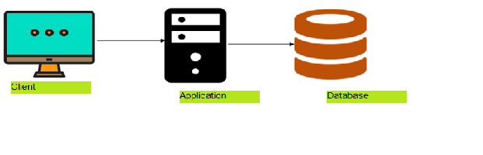

**Client tier** -. The client tier consists of application clients that access a Java EE server and that are usually located on a different machine from the server. The clients make requests to the server. The server processes the requests and returns a response back to the client. Many different types of applications can be Java EE clients, and they are not always, or even often Java applications. Clients can be a web browser, a standalone application, or other servers, and they run on a different machine from the Java EE server.

**Application tier** - The application tier, which may also be referred to as the logic tier, is written in a programming language such as Java and contains the business logic that supports the application’s core functions. The underlying application tier can either be hosted on distributed servers in the cloud or on a dedicated in-house server, depending on how much processing power the application requires.

**Data tier** - The data tier consists of a database and a program for managing read and write access to a database. This tier may also be referred to as the storage tier and can be hosted on-premises or in the cloud. Popular database systems for managing read/write access include MySQL, PostgreSQL, Microsoft SQL Server and MongoDB.

## **System context**

Writing code might be one of the more complicated parts of web development, but it’s hardly the only component. We also have to build our backend and front-end site structures and design. The backend handles the data that enables the functionality on the front-end. For example, Facebook's backend stores my photos, so that the front-end can then allow others to look at them. It’s comprised of two major components: Databases, which is responsible for storing, organizing, and processing data so that it’s retrievable by server requests. Servers, which is the hardware and software that make up our computer. Servers are responsible for sending, processing, and receiving data requests. They’re the intermediary between the database and the client/browser. The browser will, in effect, tell the server "I need this information", and the server will know how to get that information from the database and send it to the client. These components work together to build the foundation for each website.

System Context is very important term in the software development. System context in term of VR Buildtech can be described as all the event and processes including persons, organization, and document used or relevant to the system. The context diagram is used to show the relationship between the participants of the website. In VR Buildtech website and mobile apps. The admins are main participant related to the website.

## **User Interface / Interaction Design**

**Site map**

**HTML**

HTML should be use on delivering a better user experience. While, to date, only mobile websites benefit from user experience ranking on Google, it’s probably fair to infer that in the future this will also be true on all platforms. Some key considerations for our HTML include:

Use ALT tags - ALT tags are used in conjunction with images; they let convey additional information about the image that isn’t displayed as part of the main text. ALT tags assist with indexing in search engines (they let you tell the search engine about the content of the image). They also help with screen-reader narration for visually impaired users.

**Visual Factors**

The visual factors that impact the overall user experience are the factors where, normally, the designer have the most control. That means paying careful attention to.

**Font Size and Colour**

Choose fonts that are easy to read. That means high levels of contrast with the background and font sizes large enough for users to read easily. If some of our user base is elderly or visually impaired, make fonts larger.

**Branding**

Branding, in particular the company logo, helps users know where they are online. Based on eye movement patterns, the ideal place for the logo is the top-left corner of the screen. This is where users who read from left to right are most likely to look when first arriving on the site.

**Layout Colours**

Colours need to be consistent in order to convey branding and also to develop an aesthetic appeal. In addition, they must deliver readability. Often, they need to convey hierarchy of information, too.

**Navigation**

For users to get the most from a website, they need to get from point A (the entry point) to point B (where they want to be) as quickly and easily as possible. That means providing useful navigation systems, including (for larger websites) search functions, to facilitate that transition.

**Content**

The web designer may or may not be responsible for creating the website copy, but there are design elements in the way our display that copy for user experiences:

**Headings**

Organize content into manageable chunks through the use of headings, sub-headings, etc. This means developing a scheme for consistent display of each type of heading throughout the website, ensuring a consistent experience as users navigate around the site.

**Paragraphs**

Make paragraphs clear and easily recognizable to help prevent the user from being overwhelmed by a “wall of text”. We can also apply Gestalt principles to paragraphs to help better illustrate the relationships between blocks of content.

**Website Usability Tools**

Testing our website is easy, thanks to a host of tools. Many are free; some are freemium, others premium. Get one that works for our website, then let it gather the data about usability. Many let the test on our existing usership; we can tell from the data what they’re experiencing, what’s going right and not-so right. Here’s a list of some: Usabilla ,Webpage FX and Pingdom

## **Data model and software design**

RD Cleaning company website will be using MySQL Database. MySQL Database is an open-source and relational database management system. The database named after website RD cleaning will contains all data and information which are used in the website. The database will have mainly seven tables, User, Post, Event, Service, Blog, Favourite and Chat. And user service some associative tables.

ER Diagram stands for Entity Relationship Diagram. It shows the relationship of entity stored in the database. It contains, entities/class, attribute and relationship between them. ER Diagram are used to describe logical structure of database (.

**Data Dictionary** provides the brief description about the entity and attributes. The below table describe the class, field name and their datatype, constrain and description.

|  |  |  |  |  |
| --- | --- | --- | --- | --- |
| Entity/Class | Field Name | Datatype | Constrain | Description |
| CUSTOMER | **CUSTOMER_ID** | INT(11) | Primary Key | user id for verification |
|  | F_NAME | VARCHAR(255) | NOT NULL | To store user first name |
|  | L_NAME | VARCHAR(255) | NOT NULL | to store user last name |
|  | EMAIL | VARCHAR(255) | NOT NULL | to store user email address |
|  | PASSWORD | VARCHAR(255) | NOT NULL | to store user password for verification |
|  |  |  |  |  |
| LOGIN | **LOGIN_ID** | INT(11) | Primary Key | Login id to access the webpage. |
|  | F_NAME | VARCHAR(255) |  | Given Name of person |
|  | L_NAME | VARCHAR(225) |  | Family name of person |
|  | Password | ENUM | DEFAULT NULL | For login. |
| ORDER | **ORDER_ID** | INT(11) | Primary Key | event id of particular event |
|  | DATE | VARCHAR(255) | NOT NULL | to store images URL. |
|  | *CUSTOMER_ID* | INT(11) | Foreign Key | foreign key references to user. CUSTOMER_ID |
| MANAGER | MANAGER_ID | INT(11) | PRIMARY KEY | unique key to store service details |
|  | DATE | VARCHAR(255) | NOT NULL | to store title of service. |
|  | *ORDER_ID* | INT(11) | Foreign Key | foreign key references to user. ORDER_ID |

* **Use Case Diagram:**

## **Assumptions**

There are new devices, new browsers and many new features we’ll witness with the maturity of HTML5 and new JavaScript libraries which seem to popup every week.

Apart from everyone’s favourite catch phrase “responsive design”, there are other challenges we face with new devices being released every month. New patterns of interaction are required, and these interfaces need to work on any device. Maybe it’s time to reconsider the massive jQuery UI based carousel on the home page which we all love so much. Maybe the full screen gallery which looks great on our 24-inch desktop monitor (which the customer also loves) so much will be so great on our phone’s 960 × 640 resolution.

Our highly professional website design principles are based on informed research and best user experience practices. Prototyping the user journey through the wire framing process allows us to factor in the most efficient way of connecting our customers to our products or services into the designs. Web design infused with energy, delivering engaging customer experiences Global Screen Size Diversity Infographic.

As if the product that we are asked is only for android and desktop, not for another operating system. So, if they change then the vision document should be changed or updated. And it may be updated after the client meetings too as per their request.

## **External Dependencies**

The HTML and OHO language depends on the presence of webserver software that includes an AMPP Package .These can be provided by HTML AND PHP programming built in it system or it can be provided by some other third party webservers, Such as WampServer.

*.*

# **Reference**

(Sciencedirect, 2020)*https://www.sciencedirect.com/topics/computer-science/external-dependency*

(Developer, 2020)*https://www.toptal.com/javascript/a-guide-to-managing-webpack-dependencies*

(Hubspot, 2020)*https://blog.hubspot.com/website/website-development*

(Oracle, 2020)*https://docs.oracle.com/cd/E19226-01/820-7759/gcrla/index.html*